A Level qualification reform 2016

This document will help you understand the national A Level changes that came into force in September 2015.

AS and A Levels are being reformed in stages.

Phase One A Level subjects (changed Sept 2015) | Phase Two A Level subjects  (will change Sept 2016)
English literature | Philosophy
Biology | French
Chemistry | Spanish
Physics | Geography
Art | Music
Psychology | Theatre Studies
Computer science  (formerly computing) | Phase Three (from 2017 – will remain in the old system for those starting Y12 in 2016)
Economics | Mathematics  (including Further Mathematics)
History | Film Studies
This means a student wishing to study one of the subjects listed in phase one or two will be examined under a new system. For these subjects there is a significant change to the way that a student will be examined.

AS levels in the above yellow subjects are stand-alone qualifications. The students’ AS grade will no longer contribute to an A level grade.

From September 2016 we will be offering AS qualifications. Students are able to select subject(s) they wish to take AS qualifications in after the January mocks. They also have to option to ‘drop’ a subject, going from 3 to 4 A subjects for example.

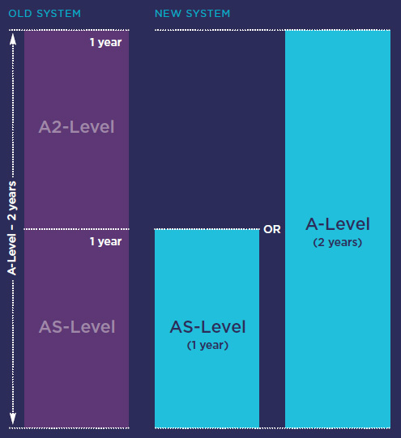
At Elthorne students will continue to sit AS level examinations in Film and Mathematics for one more year. This will mean 50% of the exams are completed at the end of year 12 in those subjects (see purple bar in the diagram).

We anticipate that most students will start with 4 subjects and select one subject to drop after the mock exams. This way the student can make an informed decision as to their weakest subject. We advise at least one AS is taken to demonstrate good performance in exams to universities. This will often be the strongest subject. Students will not have to take AS qualifications in all subjects.

